Overview
The UQ Reportal (BusinessObjects) will be upgraded in early 2024. The upgrade will apply to all users of the UQ Reportal across UQ as well as Guest users.
The existing resources and how-to documents will be updated to reflect the changes in the latest version.

Contents
This document outlines the major changes in BusinessObjects 4.3 and will provide a comparison between the current system and the new system. It includes information on:
- BI Launch Pad
  - Home page
  - Favourites
  - Recent Documents
  - Applications
- Reading Mode toolbar changes
- Design Mode toolbar changes
- Folder management features
- Managing open documents
- Prompt panel changes
- Category changes

BI Launch Pad
When the Reportal is launched, it will open on the BI Launch Pad. This home page provides easy access to folders, reports and the inbox using tiles.
It is divided into five sections, indicated by tabs at the top of the page - Home, Favourites, Recent Documents and Applications.

Home page
The tiles allow access to Folders, Categories, Documents, BI Inbox and the Recycle Bin.

Current look
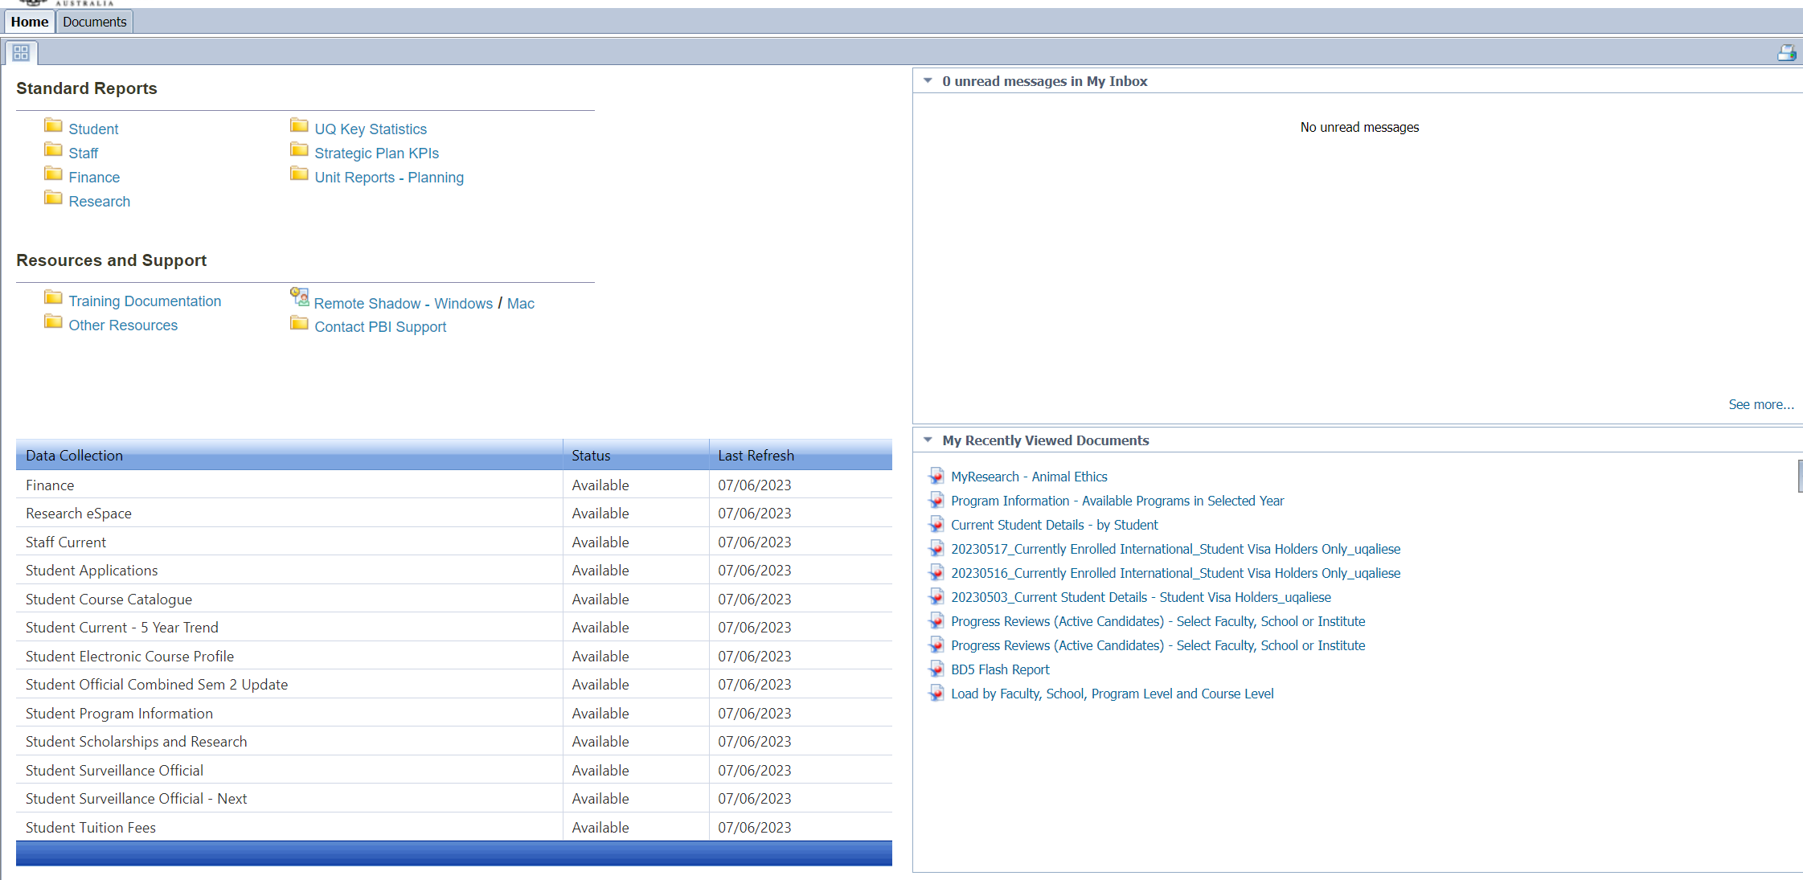

New look
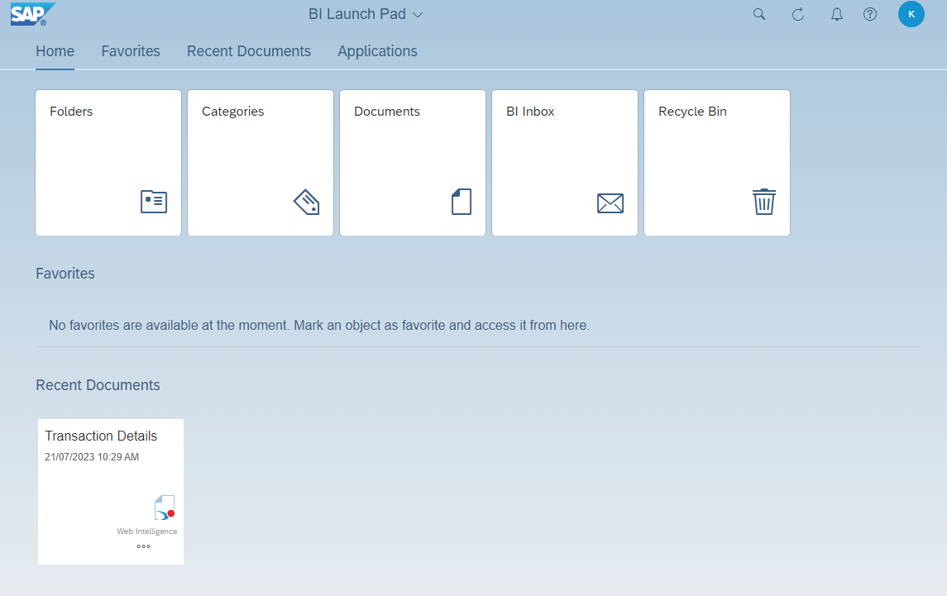

Favourites
The Favourites section displays tiles to open reports and folders you have marked as favourites, without having to navigate to their saved location. If you have more favourites than can be displayed on the BI Launch Pad, it displays the most recently accessed favourites and adds a link to view all favourites.
New favourites section
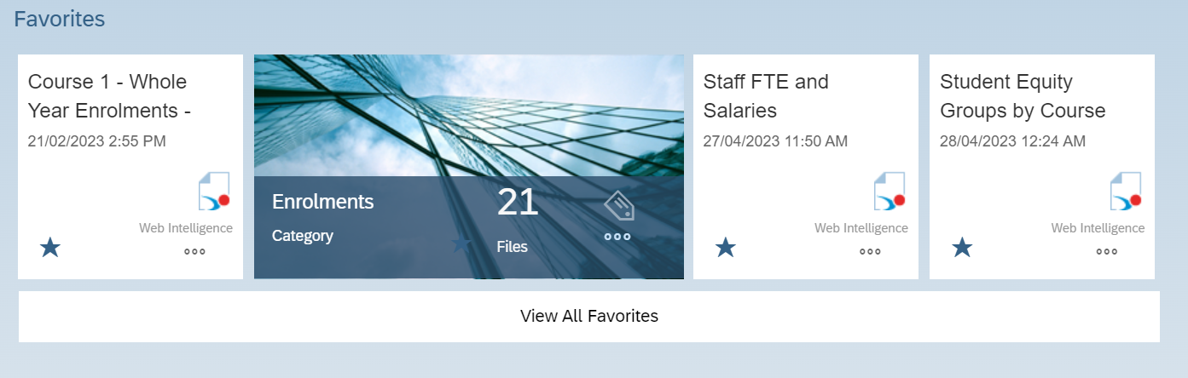

The Favourites section is not the same as My Favourites in the current version of Reportal. In the new version, Personal Folders, accessed via the Folders tile, corresponds with My Favourites.
How you currently access personal folders and documents via My Favourites

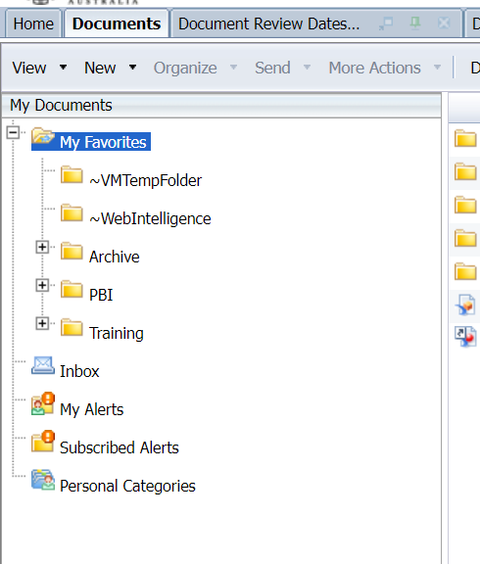
How they are accessed in the in 4.3 via Personal Folders
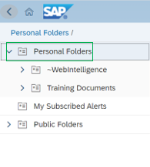

Recent documents
The Recent Documents sections show documents you have recently accessed. Previously this was My Recently Viewed Documents. Click a tile to open the document.
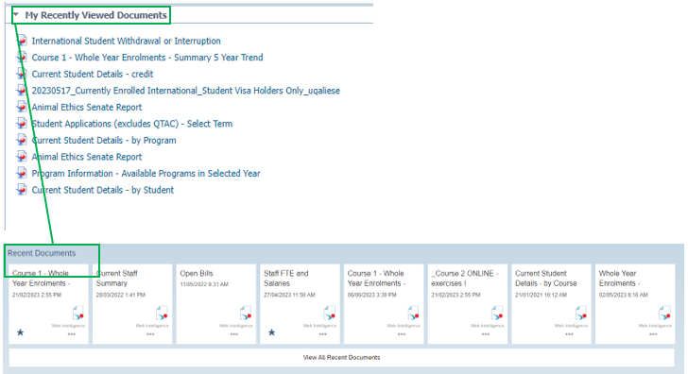

Applications
The new Applications tile was previously access from the top toolbar under a drop down.
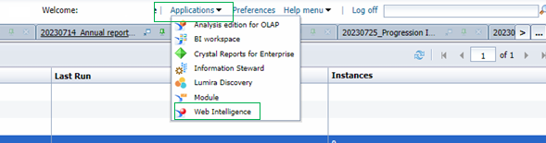
Now you can access the Applications menu quickly by clicking on the tab to jump to the tile on the page or click directly on the tile.
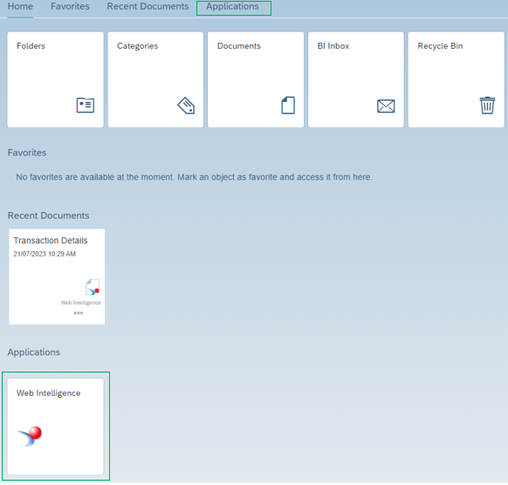

Reading Mode Toolbar changes

The toolbar used in Reading mode within 4.3 has been simplified. Some of the options are now only visible via drop-down lists and ellipsis (three-dot ‘more’) menus.
The ability to save and export a report in Reading mode is in the File section of the Reading toolbar. The option to refresh/run a report is in the Query section.

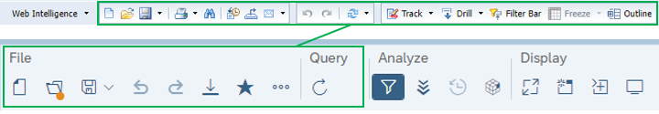

Design Mode toolbar changes
All design functionality is still available. Apart from the most used functions, you now access options from drop-down lists or the ellipsis menus.

Report Elements functions are now in the Insert section

The Insert section of the 4.3 toolbar displays icons to insert tables, charts, and cells, along with an icon to insert a section. Click the ellipsis to add shared and custom elements.

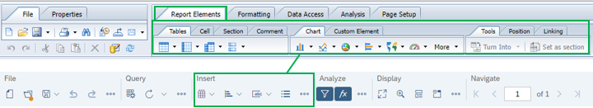

Data Access functions are in two places

Within the Data Access tab in the old version there were two subtabs, Data Providers and Data Objects.
The Data Providers functions in the new version are on the toolbar in the Query section. To add a new variable like you would from the Data Objects subtab, click on the Add a new variable icon that displays in the Main panel in Design mode.

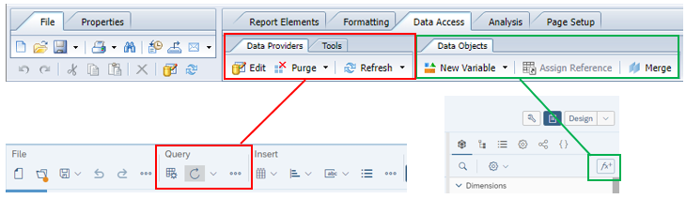

Analysis options are now in the Analyze section from the toolbar

There are icons for showing/hiding the filter bar and formula bar. Click the ellipsis menu for options to drill down, show changes, track data changes, and access formatting rules.
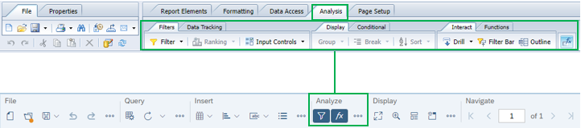
Page Setup functions are now in two places

The existing Page Setup tab in 4.2 has been extrapolated to exist in two places within 4.3. There are functions in the Display section of the toolbar. Additional functions such as New, Duplicate and Rename are available from the drop-down list next to the report name.

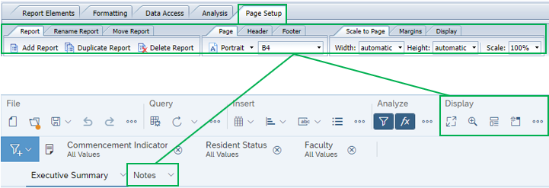

Formatting options are on a side panel

The previous Formatting tab options are now located on the data/format panel on the right-hand side. Select the Show report element format icon (indicated by the red outline below) to show the options for Display, Appearance and Layout settings (indicated by the green outline below).
Note: The table and cell formatting options are also available by right-clicking on the element and using the contextual menu, the same as in the previous version of the UQ Reportal.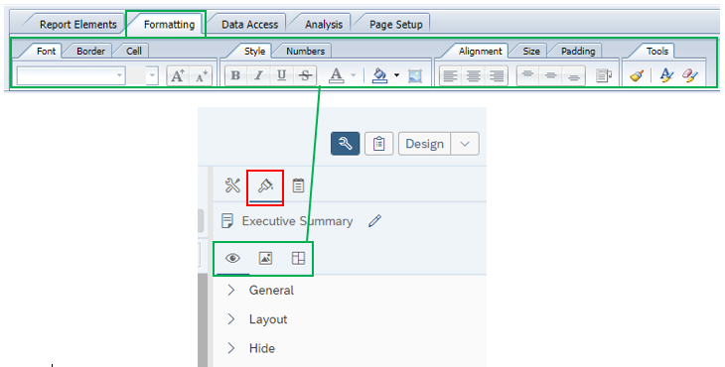

Folder management features
When viewing a folder you can see the breadcrumb navigation at the top of the page. You can click on any of the parent folder links to open that folder.
The ellipsis menu on the right provides access to view folder Properties, mark a folder as a favourite, get folder details, cut/copy the folder, and delete the folder.
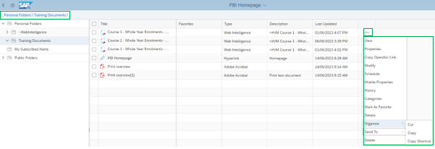

There is also a (+) Create/Upload Objects menu with options for New Folder, Publication, Upload Document, and Hyperlink
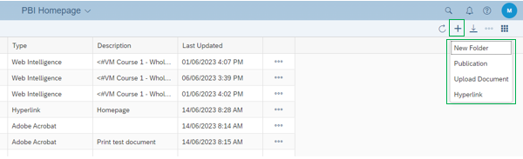

Managing open documents
Reports no longer open in separate tabs along the top of the page. By default, they will open within the current window. Click the drop-down list from the Report name at the top to view all opened and pinned documents. Click a document to open it or click the X to close it.
The below shows how multiple documents are opened and available to access within the BI Launch Pad tab of the new version of UQ Reportal under the drop-down list.
Just like in 4.2, this preference can be changed within the Account Preferences in Settings on the 4.3 BI Launch pad to open documents in a new window.
You can also Pin documents from the drop-down list using the pin icon next to the document name. Pinned documents will appear on the list when you log into the Reportal next time.

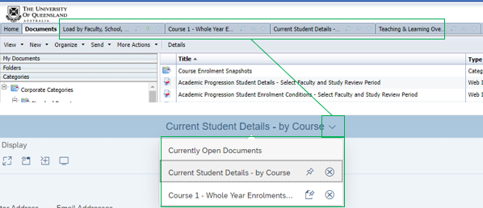

Prompt panel changes
Reports with prompts have changed in how values are selected. This means that rather than moving values from one column to another, values are selected using checkboxes. This allows you to quickly select multiple values.
Below shows the differences between the 4.2 Prompts window and the BO 4.3 Prompts window.
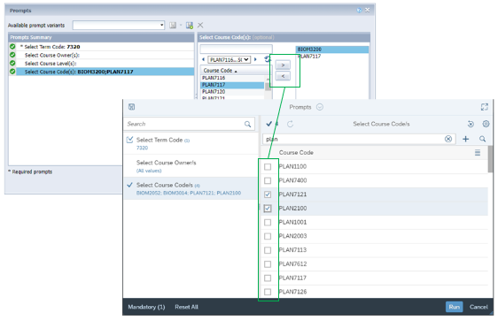

Category changes
The Categories tile allows users to arrange files and folders based on labels created. Categories are unique to each user, so you can develop a structure which aligns with how you use the UQ Reportal.
There is no limit to the number of categories allowed, and files can be assigned to more than one category. Categories are accessed from a tile on the BI Launch Pad.

Below shows the Categories feature, which looks like older folder navigations. Use the Create Category (+) icon to add a new category.

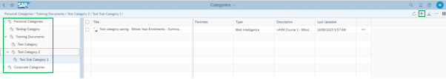

When saving documents to categories, you can multi-select to assign the document to a folder and categories.

